**I.T.U.**

**Faculty of Electric-Electronic**

**Computer Engineering**



Lesson name: Object Oriented Programming

Lesson Code: BLG252E

Name Surname: Abdullah AYDEĞER

Number: 040090533

Instructor’s Name: Sanem SARIEL TALAY

Due Date: 26.05.2011

**What This Report Includes?**

* **Introduction**
* **Classes**
* **UML Diagrams**

**Introduction**

I’ve used Microsoft Visual Studio compiler to compile my codes. I wrote class for solving the game with recursion. But I have some run-time error which I can’t understand why they exist. In my homework, I add all people to id’s and control all states with their id’s. Therefore, person names can be changed or can be entered by user. In Container I added people with their id part. For example; Father id = 0 and first element of generic array is Father. But missing part of my homework, Son1 and Son2 has the same id, and so on program is trying to add two different people(in same class) in the same memory location. Consequently, for some situations, my codes can’t work properly.

**Classes**

* **Game**

All methods and members can be shown in the UML diagram (last page of the report). Necessary comments are on the code can be seen in the figure.

This class is used for controlling inconsistencies while solving game with recursion (letsTry function).

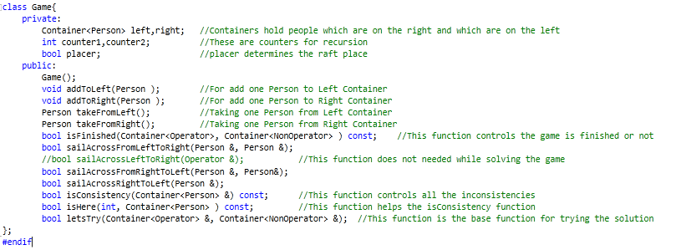

* **Container**

All methods and members can be shown in the UML diagram (last page of the report). Necessary comments are on the code can be seen in the figure.

This class is needed for holding data in containers. In this design containers are generic arrays.

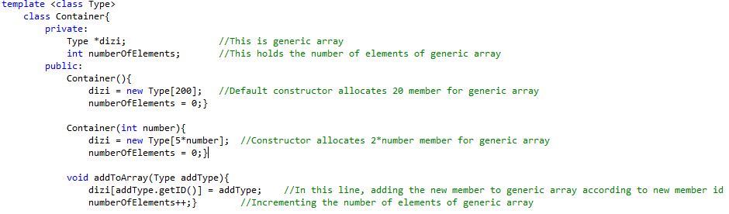

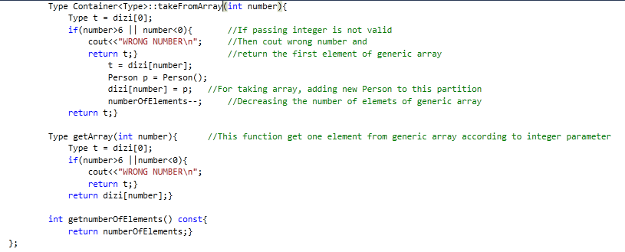

* **Person**

All methods and members can be shown in the UML diagram (last page of the report). Necessary comments are on the code can be seen in the figure.

This class is used for showing all people’s requirements.

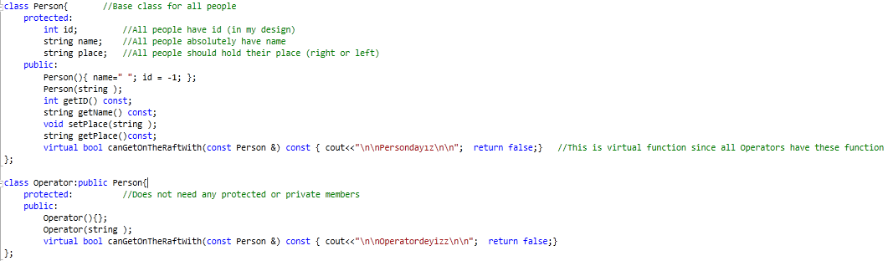

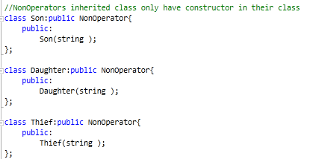

**UML DIAGRAMS**



**Game Container**

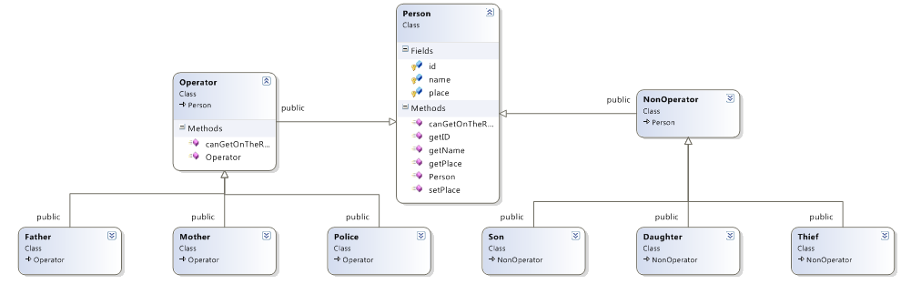

**Person**